**EE 390 Lab Project**

**Term 213**

In the lab project, you will be applying the knowledge acquired in this course to calculate basic reliability indices commonly used to assess the performance of any power system, and signal processing concept.

**The Complete code must be written in single assembly file.**

* You must use small mode. (do not use tiny mode)
* You must submit one asm file named yourname.asm that contains all parts
* **Your first line of code must start from address 0h.**
* Your ORG for all matrices must be in the first lines of your assembly code (not saved at 0h)
* Your data must be stored using DB in addresses given
* Do not change the Data from their required location in ROM
* Include sjmp $ so that I can run the program all at once
* If I cannot run all programs in one file, you will get zero even if you did all parts. It will be your job to put all the parts in 1 asm file and when I run it, all results are shown in External RAM.
* No partial grades for incomplete parts.

|  |  |  |  |
| --- | --- | --- | --- |
|  | Operation | Result (External Memory) |  |
| 1 | Transfer Matrices  S  G  L | To locations  00H  10H  20H |  |
| 2 | Calculate wind power output | Store Result at 50H-58H |  |
| 3 | Calculate loss-of-load expectation (LOLE) | Store Result at 60H |  |
| 4 | Calculate loss-of-load probability (LOLP) | Store Result at 70H |  |
| 5 | Calculate total energy served (ES) | Store Result at 80H- 81H |  |
| 6 | Calculate total energy not served (ENS) | Store Result at 91H -92H |  |

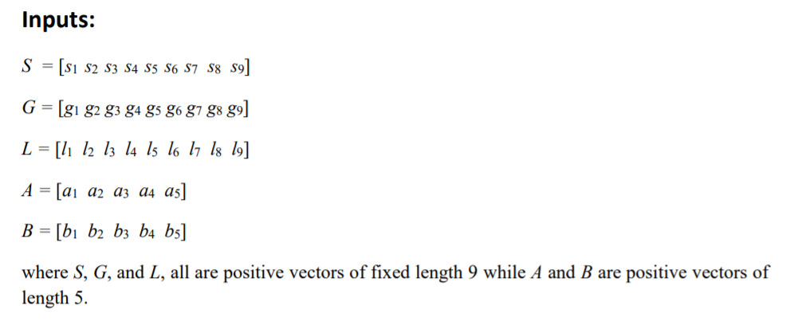

Define five variables, VECTORS, VECTORG, VECTORL in ROM to store the input vectors S, G, L.

ORG 20 h

VECTORS: DB s1, s2, s3, s4, s5, s6, s7, s8, s9

ORG 30H

VECTORG: DB g1, g2, g3, g4, g5, g6, g7, g8, g9

ORG 40H VECTORL: DB l1, l2, l3, l4, l5, l6, l7, l8, l9

**Example:**

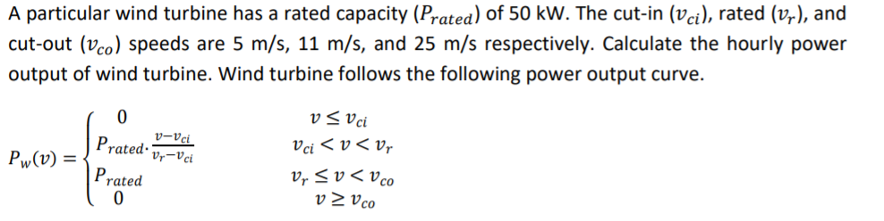

S = [45 , 4 , 0 , 8 , 11 , 29 , 9 , 5 , 6]

$$v_{ci} =5 m/s$$

$$v_{r} =11 m/s$$

$$v_{co}=25 m/s$$

Initializtion:

ORG 20H

MATRIXS: DB 45, 4, 0, 8, 11, 29, 9, 5, 6

**Result after execution of code**

At 50H onwards: 0H 0H 0H 19H 32H 0H 21H 0H 8H

|  |  |
| --- | --- |
|  |  |

|  |
| --- |
|  |

**Example:**

Calculate LOLE, LOLP, ES, and ENS for the following generation and load vectors. You will be given such generation and load profiles so that ES and ENS will not exceed 550 kW. The load or generation at any time instant cannot exceed 255 kW. LOLP can be in 0 to 100 % range.

G = [30 , 95 , 25 , 50 , 15 , 20 , 5 , 15 , 45] ; No entry can exceed 255

L = [40 , 80 , 25 , 15 , 30 , 20 , 9 , 5 , 35] ; No entry can exceed 255

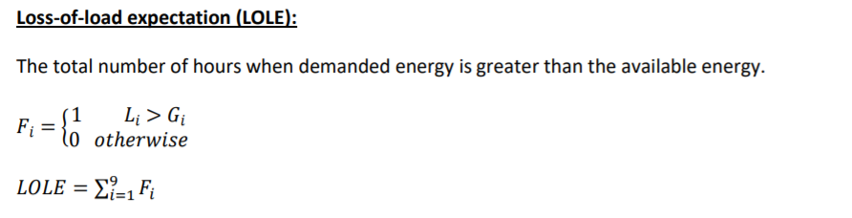

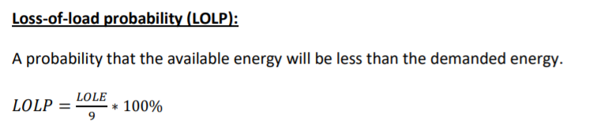

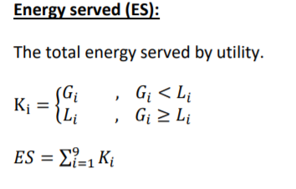

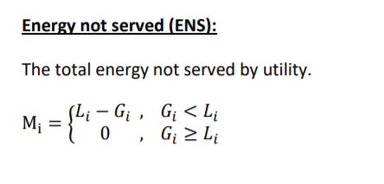

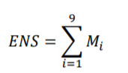

Initialization:

ORG 30H

MATRIXG: DB 30 , 95 , 25 , 50 , 15 , 20 , 5 , 15 , 45

ORG 40H

MATRIXL: DB 40 , 80 , 25 , 15 , 30 , 20 , 9 , 5 , 35

Result after execution of code

At 60H: 3D or 03H ; LOLE = 1 + 0 + 0 + 0 + 1 + 0 + 1 + 0 + 0 = 3

At 70H: 33D or 21H ; LOLP = (LOLE ÷ 9)*100 % = 33.33 %

Store Result at 80H and 81H 00E6H ; ES = 30 + 80 + 25 + 15 + 15 + 20 + 5 + 5 + 35 = 230D = 00E6H

At 90H-91H 001DH ; ENS = 10 + 0 + 0 + 0 + 15 + 0 + 4 + 0 + 0 = 29D = 001DH